OK to Pay Integration

Create invoice from SoapUI by importing Ok to Pay wsdl.

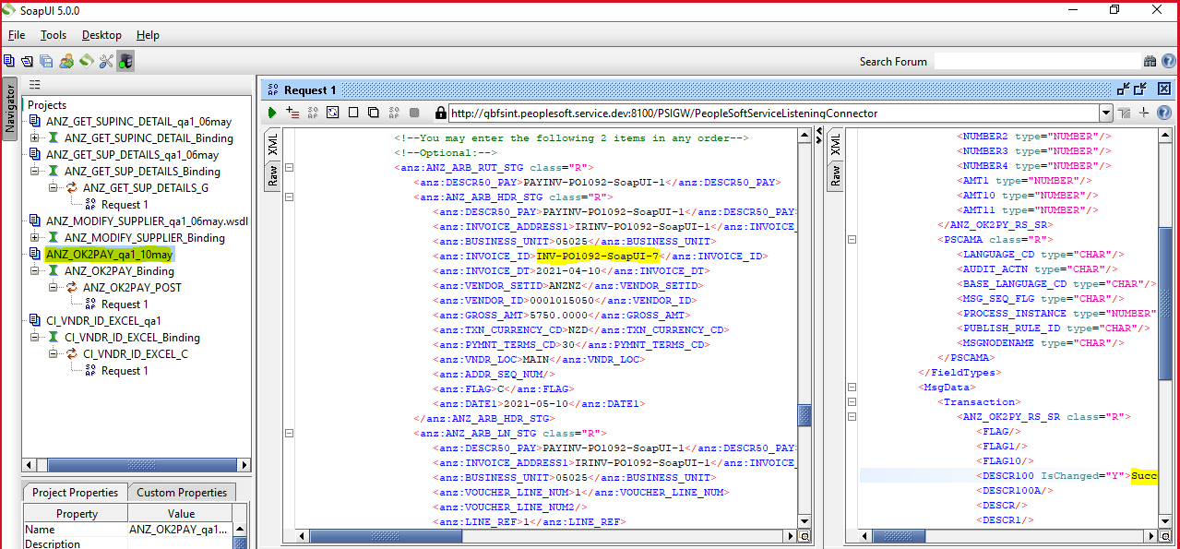

Verify the Invoice ID in the below staging table.

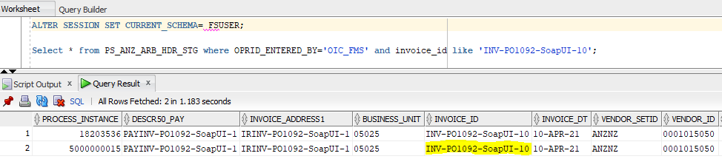

Login with PSBATCH and navigate to below page.

Main Menu- ANZ Interfaces – ANZ Interface Control – Process – JobSet Wrapper

Open with **NZL_AP_OK2PAY_VB_JS_H1** run control ID from the search page and click on **Run** button.

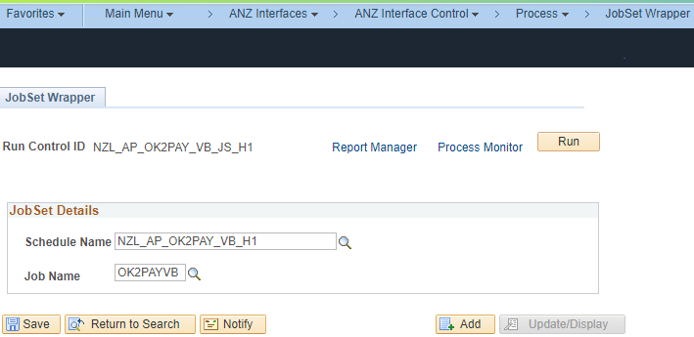

After trigger validate in the process monitor and check the run status is Success.

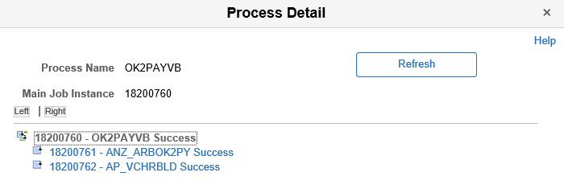

Login with super user and navigate to below page.enter BU and Invoice no in the search criteria and click on search. This page is to validate the invoice information and voucher ID along with voucher status.

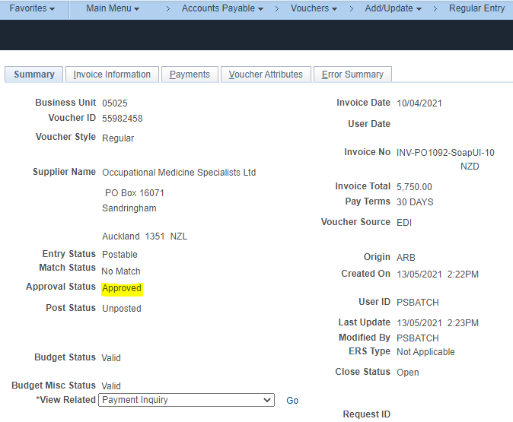

Login with PSBATCH and Navigate to the below page and post the voucher.

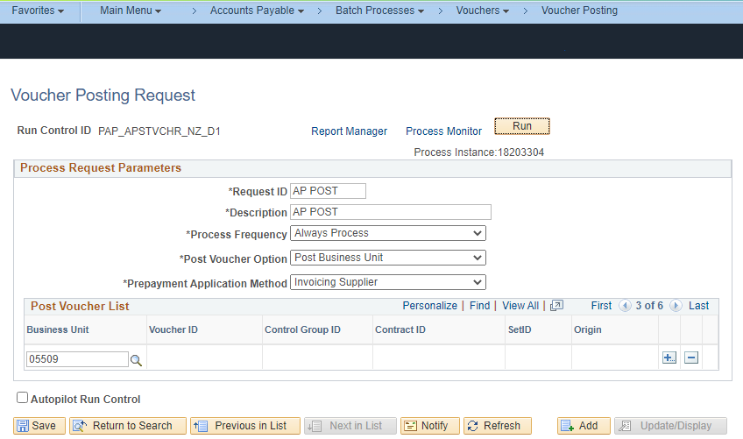

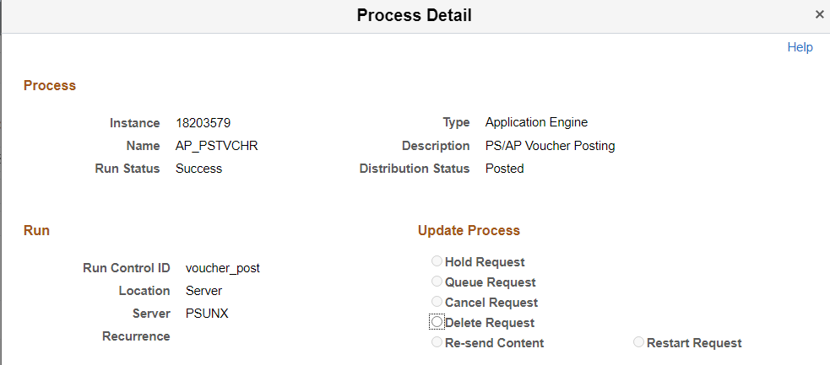

After successful posting validate the status of this voucher in below page.

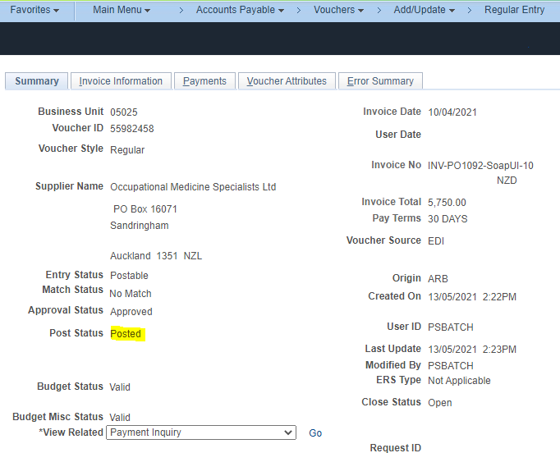

Pay cycle run every day pays this voucher based on schedule payment date. For now we have to trigger the pay cycle manually by considering the schedule payment date.

Navigate to below page. Select **APNZPC** in the search criteria and open.

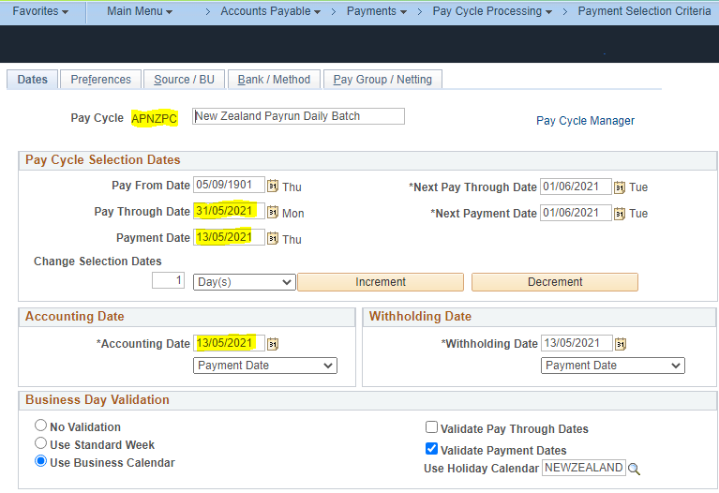

After prodviding all the valid pay cycle selection dates, navigate to below pay cycle manager page and run that marked two process.

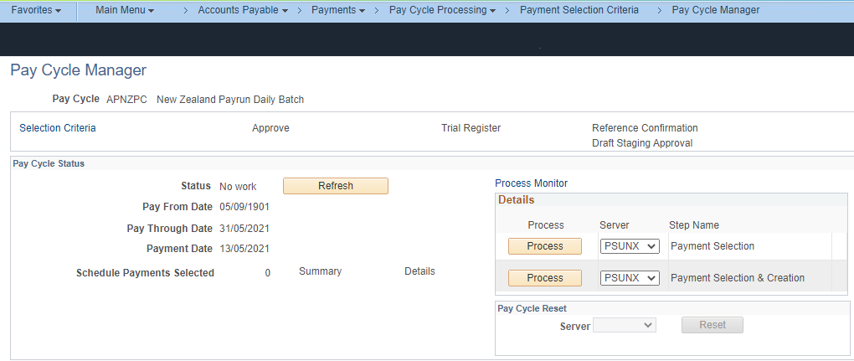

After successful payment validate the status of this voucher in below page.

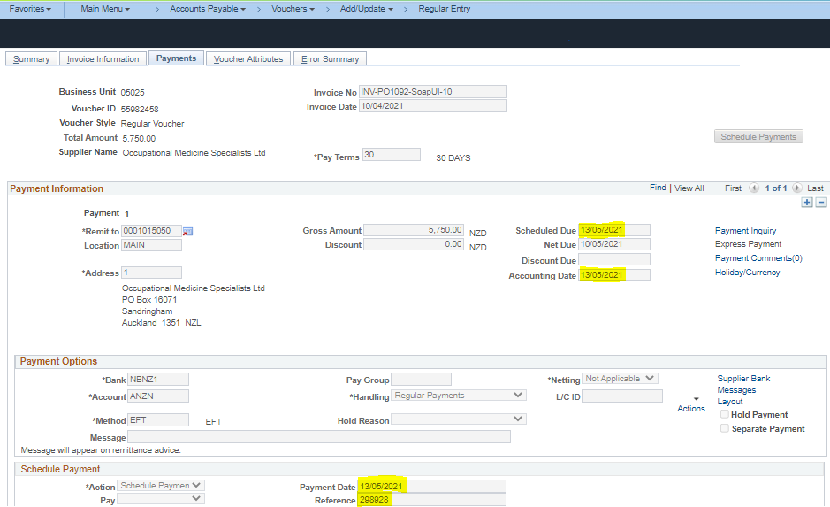

Remittance files are generated for above pay cycle and pay cycle sequence number.

Navigate to below page and provide the pay cycle detail and max sequence number in the prompt and run the process.

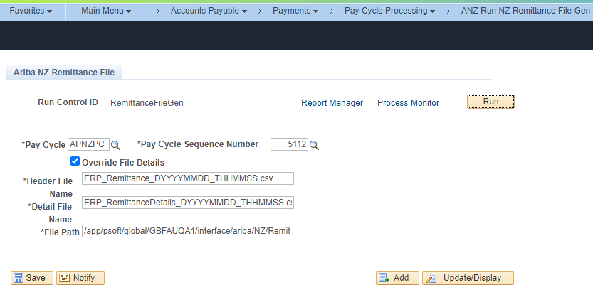

Run the process and validate the file in the specified NAS.

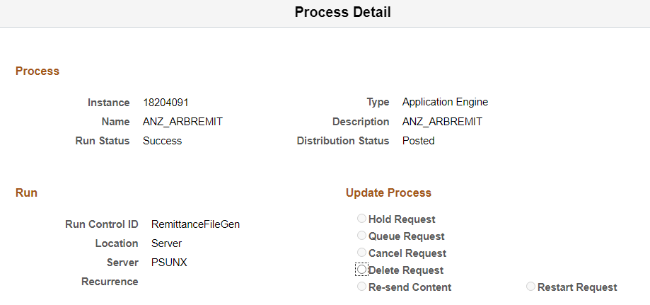

Check the files in the Log.

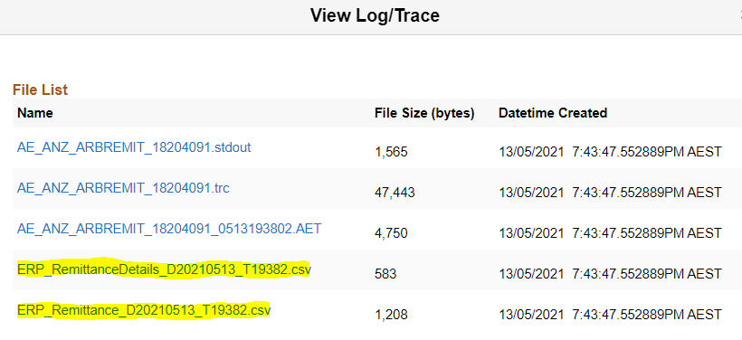

Validate the files in the NAS.

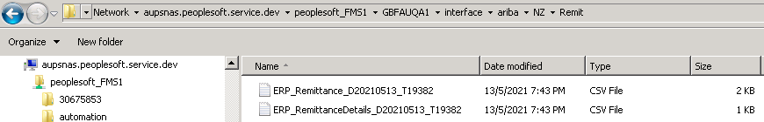

Validate the Voucher payment details in the remittance file.

